Level 3 – PL (Programming Language) and Features

1. Two procedures / functions
1. p_updatePropertyPrice: This procedure updates the price of any given property insurance policy type. It takes as parameters the base price, which is the minimum price for all policies, and the ID of the policy for which the price should be updated. It then calculates the final price for the property policy from the attributes in the property table (according to the type of property, its age, and its value) and updates it accordingly in the policy table.

create or replace procedure p_updatePropertyPrice(i_basePrice_nr NUMBER, i_policyID_nr NUMBER) is
r_prop property%ROWTYPE;
v_propFactor_nr NUMBER;
v_ageOfProp_nr NUMBER;
v_propValue_nr NUMBER;
v_resultPrice_nr NUMBER;
begin
--Load record
select * into r_prop from property where policy_ID = i_policyID_nr;
--Set type factor according to property code
case r_prop.property_code
when 1 then
v_propFactor_nr := 1.5;
when 2 then
v_propFactor_nr := 2;
when 3 then
v_propFactor_nr := 2.5;
when 4 then
v_propFactor_nr := 3.5;
when 5 then
v_propFactor_nr := 5;
else
v_propFactor_nr := 1;
end case;
--Set age of property
v_ageOfProp_nr := r_prop.age_of_property;
--Set property value
v_propValue_nr := r_prop.property_value;
--Calculate resPrice
v_resultPrice_nr := i_basePrice_nr + v_propFactor_nr*v_ageOfProp_nr*5 + v_propValue_nr/10000;*
--Update record
update policy
set price = v_resultPrice_nr
where policy_id = i_policyID_nr;
end p_updatePropertyPrice;

2. f_sumForCustomer_Nr: This function returns the total price of all the policies of a particular customer ongoing at a given date. The parameters are the customer’s ID and the said date. A cursor then loops over the customer’s policies and sums the actual prices (policy type price multiplied by the customer’s bonus), and then returns the sum.

create or replace function f_sumForCustomer_Nr(i_customerID_nr NUMBER, v_date_dt DATE)
return NUMBER
is
cursor c_custPolicy is
select * from policy natural join customers_policy
where customer_ID = i_customerID_nr;
r_custPolicy c_custPolicy%ROWTYPE;
v_sumPrices_nr NUMBER := 0;
begin
--Load cursor
open c_custPolicy;
loop
--Load record
fetch c_custPolicy into r_custPolicy;
exit when c_custPolicy%NOTFOUND;
--If policy date checks out
if r_custPolicy.start_date < v_date_dt and r_custPolicy.end_date > v_date_dt then
--Compute price of actual policy using price and bonus and add to sum
v_sumPrices_nr := v_sumPrices_nr + r_custPolicy.price * (1 - 0.05 * r_custPolicy.bonus);
end if;
end loop;
close c_custPolicy;
return(v_sumPrices_nr);
end f_sumForCustomer_Nr;
2. Two Programs for the above procedures/functions
1. This program updates the prices of all the property policies using the first procedure above (1.1). In order to do this, it uses a cursor that goes through all the rows from the property table and calls the procedure to update the relevant row in the policy table.

declare
cursor c_prop is
select policy_id from property;
r_prop c_prop%ROWTYPE;
begin
--Load cursor
open c_prop;
loop
--Load record
fetch c_prop into r_prop;
exit when c_prop%NOTFOUND;
--Call p_updatepropertyprice with base price 1000 and policy ID or each record
p_updatepropertyprice(i_baseprice_nr => 1000,
i_policyid_nr => r_prop.policy_id);
end loop;
close c_prop;
end;

Let us check: first we query the database before the changes:
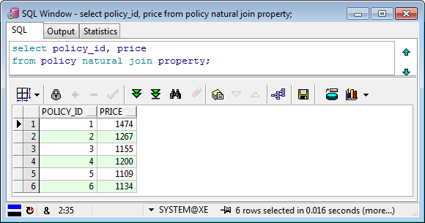

Then we run the procedure and commit:
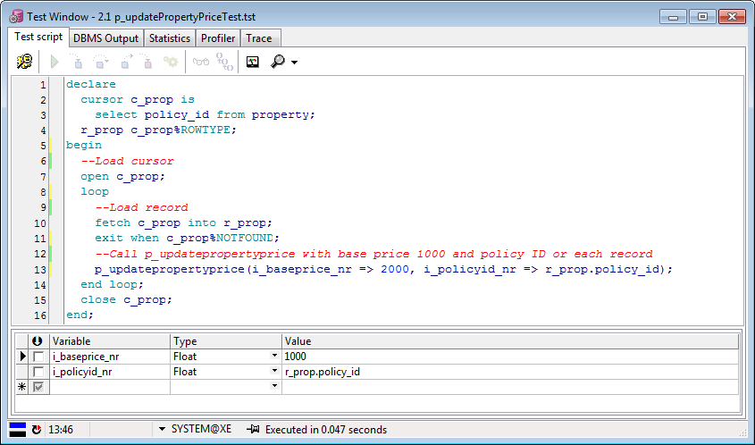

And finally we query again with the same query and notice the updated results:
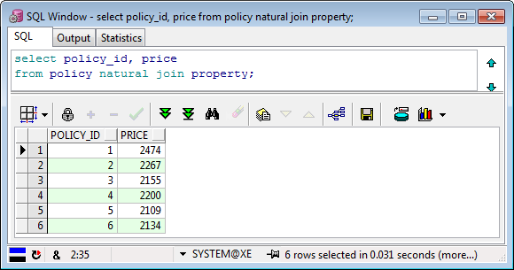

All as expected.

2. This program outputs the total price to pay for the customer_id 109418126 as of 01/05/2006.

declare
--Pick wanted customer ID
v_firstCustID_Nr NUMBER := 109418126;
v_result_Nr NUMBER;
begin
--Call f_sumforcustomer_nr on that customer for wanted date
v_result_Nr := f_sumforcustomer_nr(v_firstCustID_nr, TO_DATE('01-May-2006','dd-mon-yyyy'));
DBMS_OUTPUT.put_line('Total for customer ' || v_firstCustID_nr || ' is: ' || v_result_Nr);
end;
Let us check: we run the function:
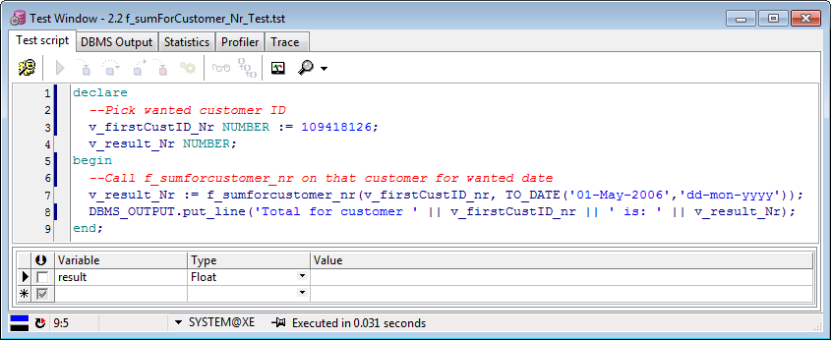

Then we read the DBMS output tab:
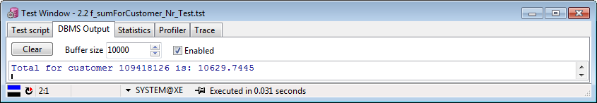

And finally we can query the database to verify that the result checks out:
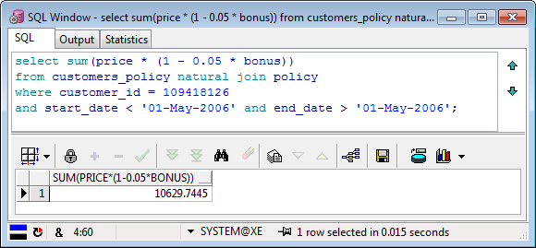

All good.

3. Two triggers
1. pol_checkDate acts like a constraint which, instead of each insert into customers_policy, checks whether the start_date is more than a month later than today, in which case it calls a raise_application_error with an informative error message (unlike usual constraints) and rejects the insert query:
:
create or replace trigger pol_checkDate
before insert or update on customers_policy
for each row
declare
v_error_tx VARCHAR2(2000);
begin
--If start date of policy more than a month from now
if :new.start_date > sysdate + 30 then
v_error_tx := 'policy start date for policy ' || :new.customers_policy_id || ' cannot be later than a month from today!';
--Reject query and print error message
raise_application_error(-20999, v_error_tx);
end if;
end property_setPrice;

And here is a program that checks the constraints by entering one legal statement and an illegal one (as of this year, 2013):

declare
begin
--Update policy with start_date a while ago
update customers_policy
set start_date = TO_DATE('01-May-2006','dd-mon-yyyy')
where rownum = 1;
--Update policy with start_date more than a month from now
update customers_policy
set start_date = TO_DATE('01-May-2016','dd-mon-yyyy')
where rownum = 1;
end;

Let’s run the above program:
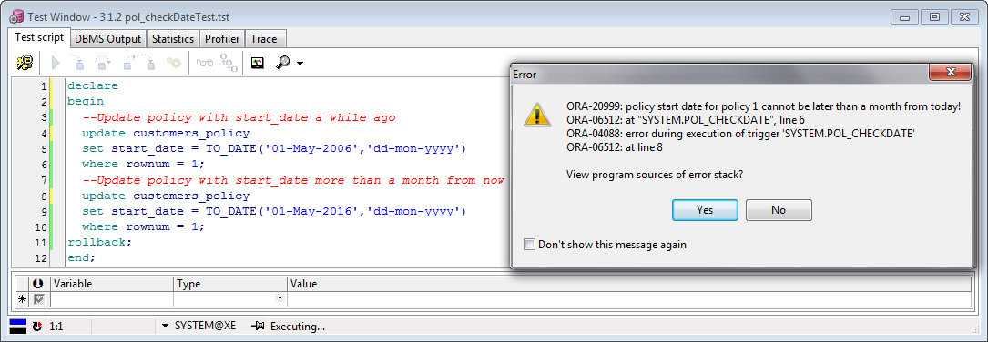

The program complained about the update at line 8, as expected.

2. cust_upperLastName forces the last_name of each new insert or update into customer to be uppercase, as is often the case in administration offices:

create or replace trigger cust_upperLastName
before insert or update on customer
for each row
begin
--Replace last_name with same string but uppercase characters
:new.last_name := upper(:new.last_name);
end cust_upperLastName;

This program tests the above trigger by updating the last_name of the first customer with the name ‘Cohen’ and then outputs the last_name as it appears in the database after the update.

declare
v_custLastName_St VARCHAR2(20);
begin
--Set first customers's last_name as 'Cohen'
update customer
set last_name = 'Cohen'
where rownum = 1;
--Get first customers's last_name and print it
select last_name into v_custLastName_St from customer where rownum = 1;
DBMS_OUTPUT.put_line('Last name of first customer is: ' || v_custLastName_St);
rollback;
end;

Let us run the above program:
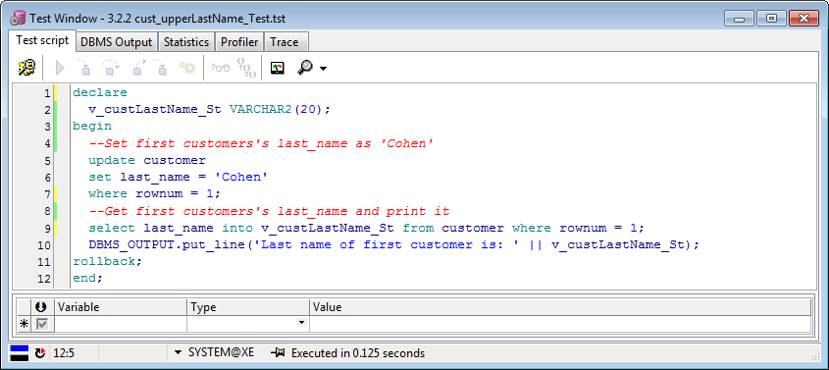

Let’s check the updated last_name using the DBMS output tab:
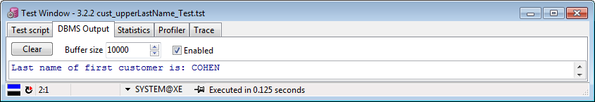

Checks out.

4. Report and Substitution Variables
1. Customers report
This report presents the customer information filtered by minimum or maximum age (we can also define a range this way), by last name and by gender (using an optional list):

select * from customer
--Only print records of customers older than this age
where (sysdate - birth_date) / 365 > &<name="Minimum age"
hint="Only customers older than this age will be shown" type="integer"
ifempty="0">
--Only print records of customers younger than this age
and (sysdate - birth_date) / 365 < &<name="Maximum age"
hint="Only customers younger than this age will be shown" type="integer"
ifempty="200">
--Only print records of customers with this exact same name
and last_name like &<name="Last name" hint="Enter the customers' last name"
type="string" ifempty="%">
--Only print records of customers with these specific genders
and gender in (&<name="Gender" hint="Select the customers' gender"
list = "0, male, 1, female" description="yes" multiselect="yes" ifempty="0 ,1">)

Let’s run it:
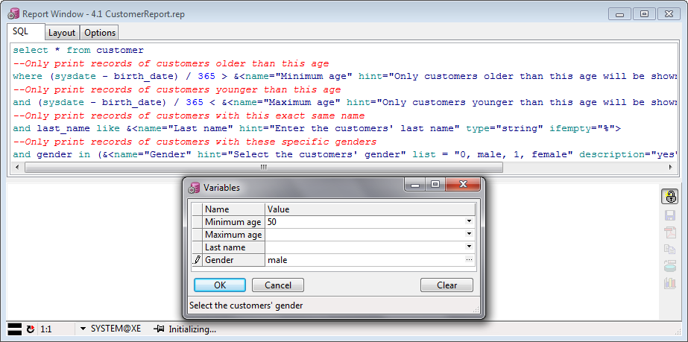

And we get this:
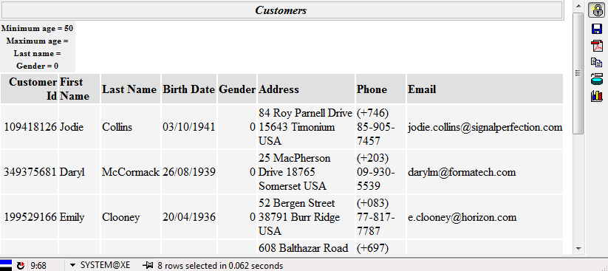

Excellent.

2. Policies report
This report presents various information about actual implemented property insurance policies, filtered by minimum start date, age of property and property code (using an optional list). It also offers a layout with ordering and block.
select policy_id, customer_id, start_date, end_date, price*(1-0.05*bonus) as price,
property_code, age_of_property, property_value
from customers_policy natural join policy natural join property
--Only print records starting after this date
where start_date > &<name="Starting after"
hint="Only policies that started after this date will be shown"
type="date" ifempty="01/01/1900">
--Only print records starting before this date
and age_of_property >= &<name="Minimum age"
hint="Only policies for properties older than this number (in years) will be shown"
type="integer" ifempty="0">
--Only print records with these specific property codes
and property_code in (&<name="Property code" hint="Select the property code"
list = "1, apartment, 2, house, 3, luxury house, 4, building, 5, other"
description="yes" multiselect="yes" ifempty="1, 2, 3, 4, 5">)
order by policy_id asc, customer_id asc

Let’s run it:
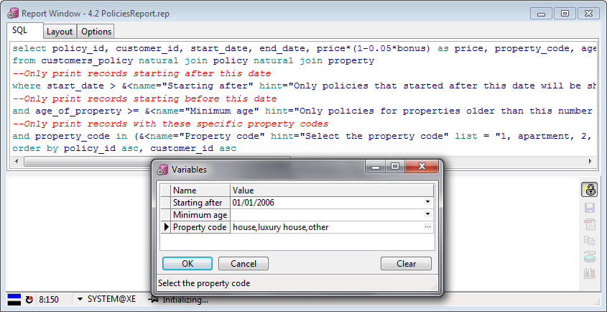

And this is the result:

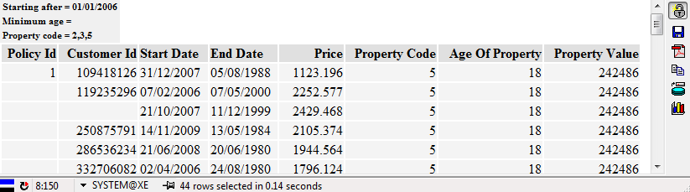

You can notice that we used the layout tab for breaks and tweaked categorization. Perfect.

